Odoo 19 for Real Estate and Property Management
Rohan Raj | Mar 12, 2026

Introduction
Managing a real estate agency means handling multiple things at once — listing properties, attracting buyers, scheduling visits, negotiating offers, and closing deals. When these processes run on disconnected tools, follow-ups get missed and deals slip through the cracks.
Odoo 19 provides an integrated solution by offering a dedicated industry configuration that sets up your database specifically for real estate workflows. When creating a new Odoo 19 database, selecting the Real Estate Agency industry automatically installs and configures the core applications needed to manage your property business from a single platform.
This blog walks through the complete real estate workflow in Odoo 19, from setting up your database and listing properties to capturing buyer interest, managing visits, handling offers, and closing deals.

Creating an Odoo 19 Database for Real Estate
When setting up Odoo 19 for the first time, the database creation screen presents an option to select your industry. Choosing the correct industry pre-configures your database with the appropriate applications, saving significant setup time.
Navigate to your Odoo instance and from the top menu, click Industries. Under Real Estate section, select Real Estate Agency. Click Start Now to begin the database setup process. After clicking Start Now, the Get Started page appears. Fill in the required details in the form and click Start Now to proceed.

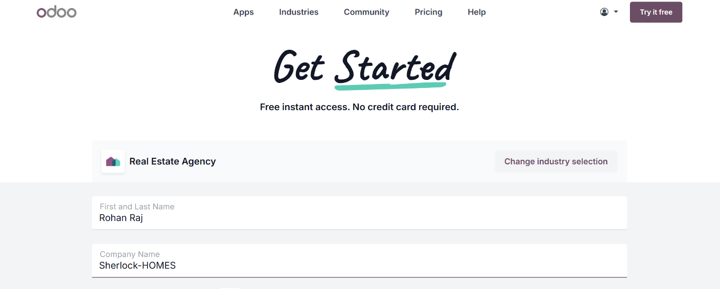

Upon selecting Real Estate Agency and confirming the database creation, Odoo 19 automatically installs several applications to support real estate operations. These include apps such as:
- CRM — for managing property leads, buyer pipelines, and customer follow-ups
- Sales — for creating commission quotations and managing seller agreements
- Appointments — for scheduling and managing property viewings and site visits
- Website — for publishing property listings publicly on your website
- Invoicing — for generating invoices and managing customer payments
- Properties — the central hub that connects and drives all your real estate operations from a single place.

These applications work together as an integrated real estate management system without requiring separate installation or manual configuration.

Managing Properties in Odoo 19
The Properties application is the core module for managing your real estate portfolio. It connects several core Odoo modules together into one seamless experience.

Creating a Property Listing
To create a new property record:
Go to Properties → Properties → New
This opens a form where property details can be entered. In Odoo, property listings are created using the product form, which is extended with additional property-specific fields.
Enter the required information here, such as the property name, price, and basic details in the General Information section.
The Attributes & Variants tab can be used to define additional property characteristics such as region, number of rooms, bathrooms, property type, and condition.
Use the Property tab to add specific real estate details such as the address, owner, agent, construction information, and other property-related data.
And finally, Use the eCommerce tab to publish the property on the website and add descriptions, tags, and images for online listings.
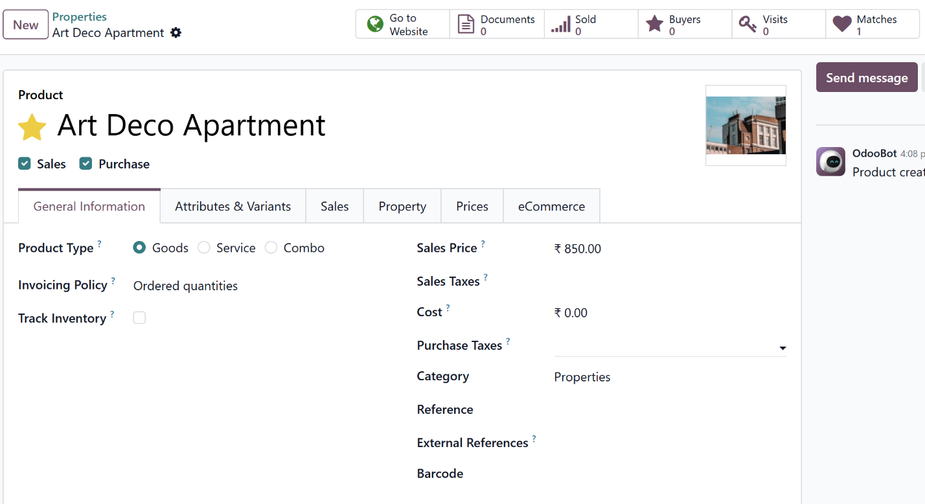
Here, you'll see a row of smart tabs at the top of the property form, which Odoo automatically fills with details from other connected apps. These tabs—like Go to Website, Documents, Sold, Buyers, Visits, and Matches—help you track everything related to your property by pulling in information from your Sales, CRM, Website and other modules.

Commission quotation

Before publishing the property, you can send a formal commission quotation to the seller of the property for approval. This quotation outlines your agency's commission rate and any service fees — it is the seller's written confirmation that they authorise you to market their property on agreed terms.

You can create a new quotation with the help of Sales app

Go to Sales → Orders → Quotations → New → Set seller as customer → Add Commission and other extra charges → Click Send

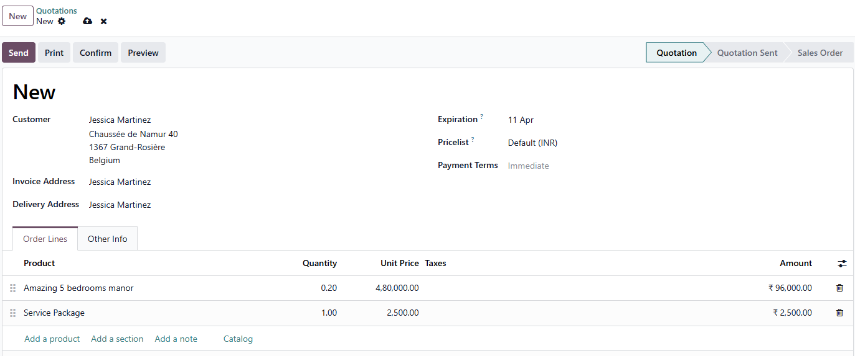

The seller receives this by email, reviews the commission breakdown on their customer portal, and clicks Accept & Sign. Once signed, it converts to a confirmed Sales Order.

Publishing the Property on Your Website

Once a quotation is converted to sales order, click the Go to Website smart button at the top of the product form. This opens the property's public listing page on your website. From here, toggle the Published switch to make the property visible to buyers online.

Go to Properties → Open property record → Click Go to Website → Toggle Published on

Visualising Properties on the Map

The Map view plots all your listed properties geographically on an interactive map. This gives agents and managers a clear picture of portfolio distribution across locations and makes it easy to respond to buyer enquiries about properties in a specific area.

Go to Properties → Map

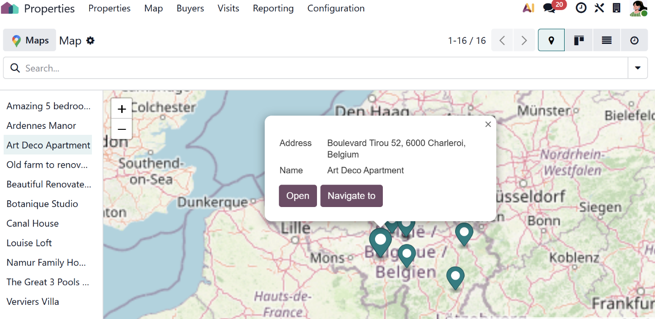

Capturing Buyer Interest

Buyers can enter the pipeline in more than one way. Agents can create records manually, but the most powerful aspect of the Odoo 19 real estate setup is that buyers can also enter the pipeline directly from the agency website — without any manual work from the agent.

When a buyer expresses interest in a property, their enquiry is recorded in the Buyers section of the Properties app. The Buyers pipeline is powered by Odoo CRM behind the scenes, which means all buyer records follow the same CRM logic — including activity scheduling, follow-up reminders, and reporting.

From the Website — Property Interest Form

Each property page on the agency website includes an Interested in this property? form at the bottom. When a buyer fills this in and submits it, Odoo 19 automatically creates a new buyer record in the Buyers pipeline linked to that specific property. The buyer appears in the New stage, ready for an agent to follow up.

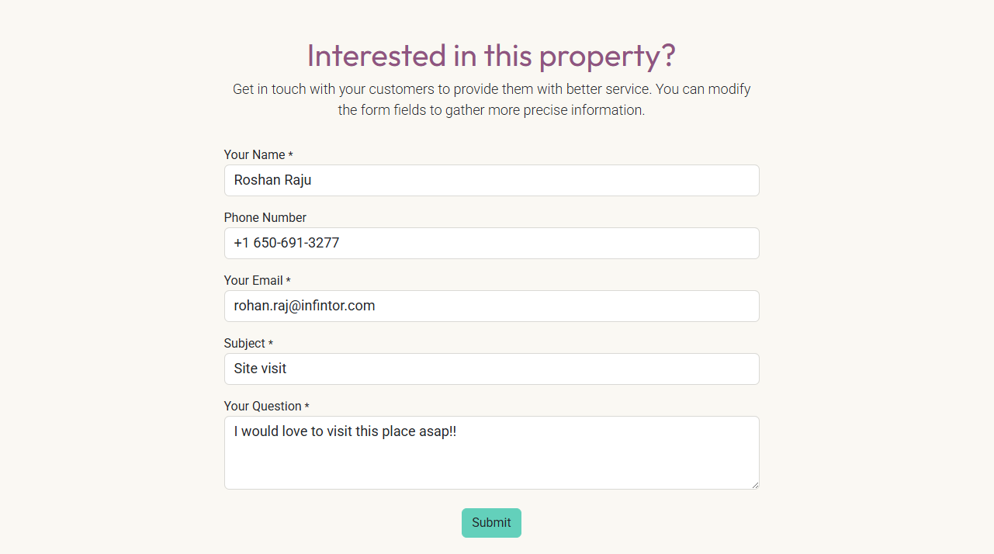

From the Website — Matchmaking

Buyers who have not found the right property yet can register their preferences through the Matchmaking section on the website. They specify their preferred region, property type, number of rooms, condition, price range, and other criteria and submit the form. Odoo 19 stores these preferences and automatically notifies the buyer when a new matching property is listed.

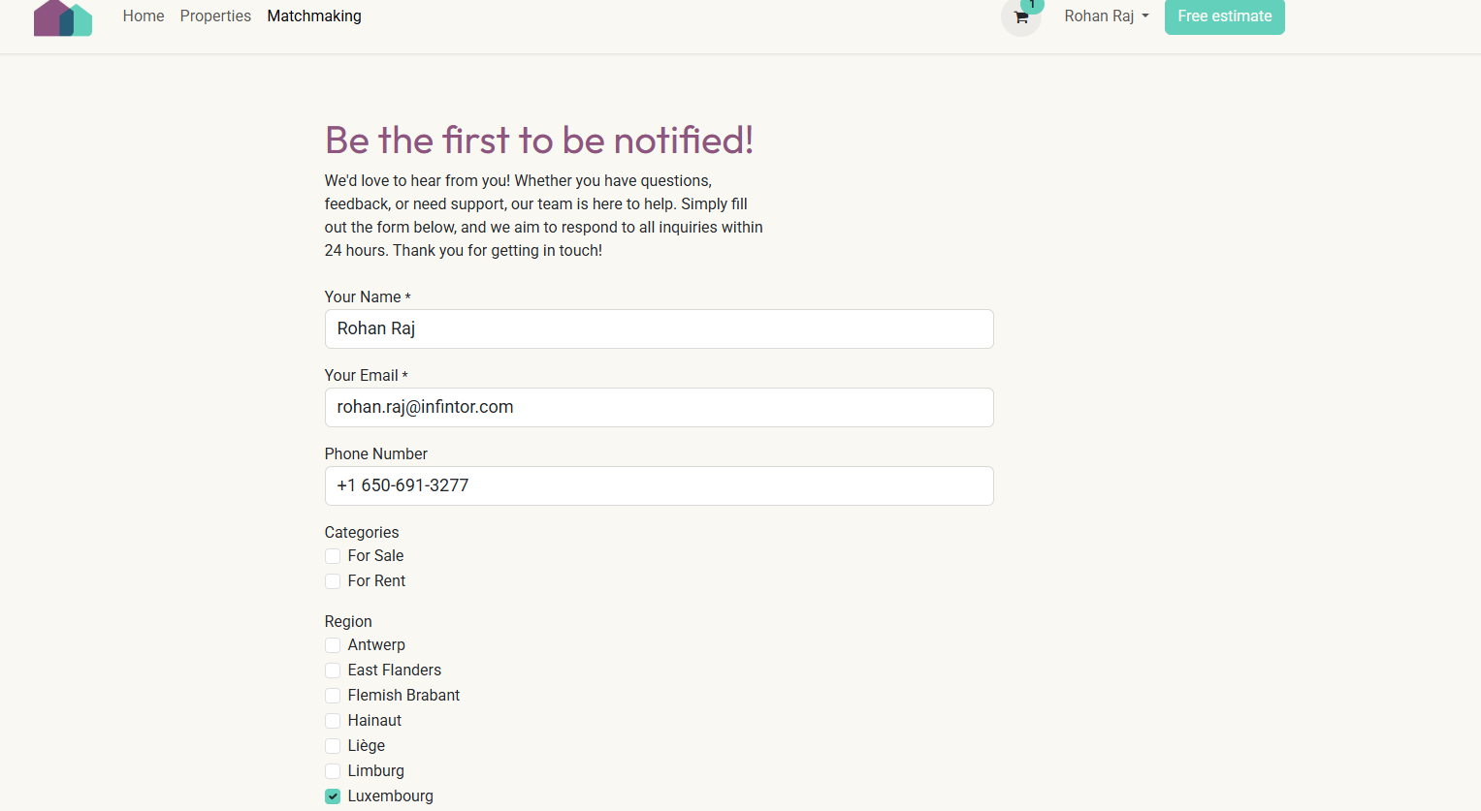

These matchmaking registrations also appear in the Buyers pipeline, allowing agents to proactively reach out to registered buyers whenever a suitable property becomes available. On the property record itself, the Matches smart button shows how many registered buyers match that property's criteria.
Adding a Buyer Manually

You can also create a new buyer record manually by entering the buyer's contact details and linking them to the property they are interested in.

Go to Properties → Buyers → New

Enter the contact details and opportunity name, then click Add. The record can then be opened to add additional details such as the property the buyer is interested in.

Managing the Buyers Pipeline

All buyer records — whether created from the website or manually — are tracked in the Buyers pipeline inside the Properties app. This pipeline is the central hub for managing every buyer's journey from first contact to closed deal.

Go to Properties → Buyers

The pipeline uses five stages, and you can move buyer records through these stages manually as the transaction progresses:

- New — buyer has expressed initial interest
- Visit — a property visit has been scheduled or completed
- Qualified — buyer has confirmed serious intent to purchase
- Offer — buyer has submitted a formal offer
- Won — the deal has been successfully closed

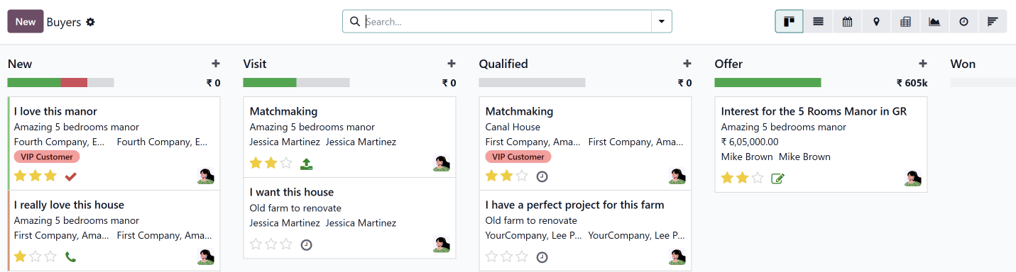

Each buyer card in the kanban view displays the opportunity name, buyer's name, the property they are interested in, and their assigned agent.

Scheduling Property Visits
Once a buyer shows genuine interest, the next step is arranging a property visit. Once a buyer shows genuine interest, the next step is arranging a property visit. Inside the buyer record, clicking the Visit button sends a branded booking email directly to the buyer. Since the Visits feature is integrated with Odoo’s Appointments module, this email includes a self-scheduling link that allows the buyer to pick a convenient date and time from the agent's available calendar — without any back-and-forth communication.
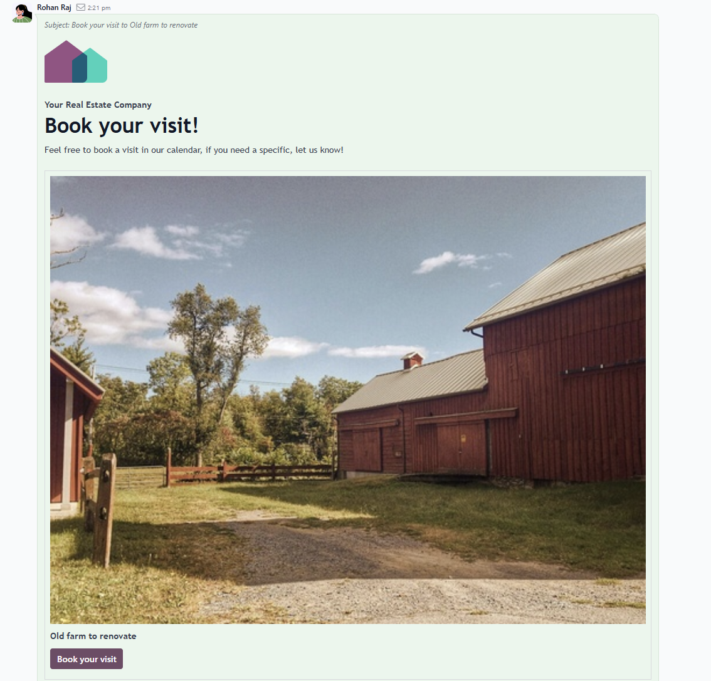

Once the visit is confirmed, the agent manually moves the buyer record to the Visit stage. All scheduled visits are visible in the Visits section of the Properties app. The Visits section displays a calendar view of all upcoming and completed property viewings.
Go to Properties → Visits
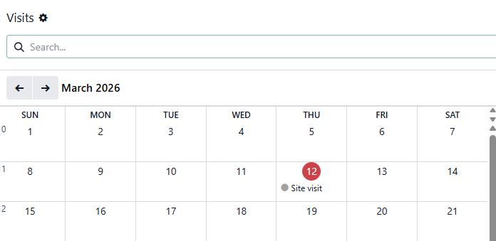

After a successful visit, if the buyer confirms they want to proceed, the agent moves the buyer record to the Qualified stage by dragging the card in the pipeline or clicking the Qualified stage button inside the record.
Sending the Offer for Digital Signature
When the buyer is ready to make a formal offer, you can move the record to the Offer stage. Now open the buyer record and click on the Offer button. This opens a signature request using Odoo Sign that helps to send an offer document to both the buyer and seller for digital signing.
Open buyer record → Click Offer button → Review signers → Click Send

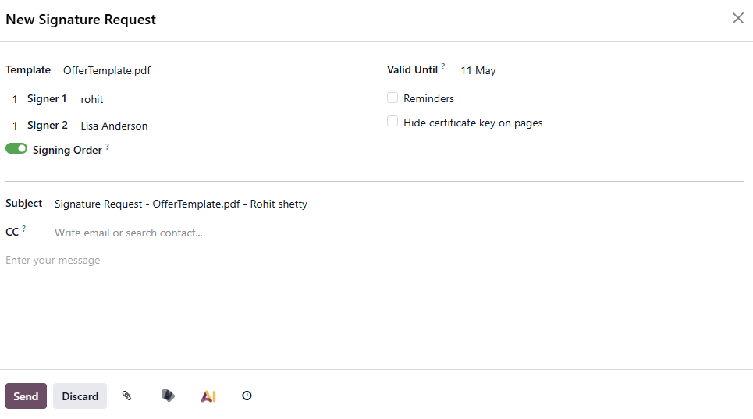
Invoicing the Commission After the Offer
Once the buyer's offer is accepted, your agency should earn its commission based on the agreed offer price. To do this, open the sales quotation you created earlier for the seller, open it and update commission line item to reflect the actual offer price, and click on create invoice
Go to Sales → Orders → Quotations → Open the seller quotation → Edit commission amount → Create Invoice

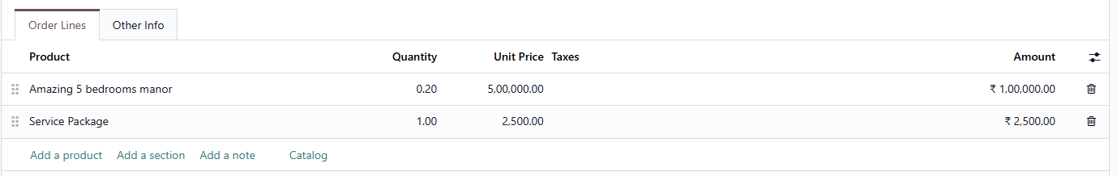

The invoice now accurately reflects the commission earned on the final offer price, along with any service fees. This is then sent to the seller for payment, completing the transaction cycle for your agency.

Properties Report
Go to Properties → Reporting
The reporting in Properties app provides a pivot table showing all the properties and their current stage counts. Use the Measures button to customise the data displayed, and the Insert in Spreadsheet option to export for stakeholder review.

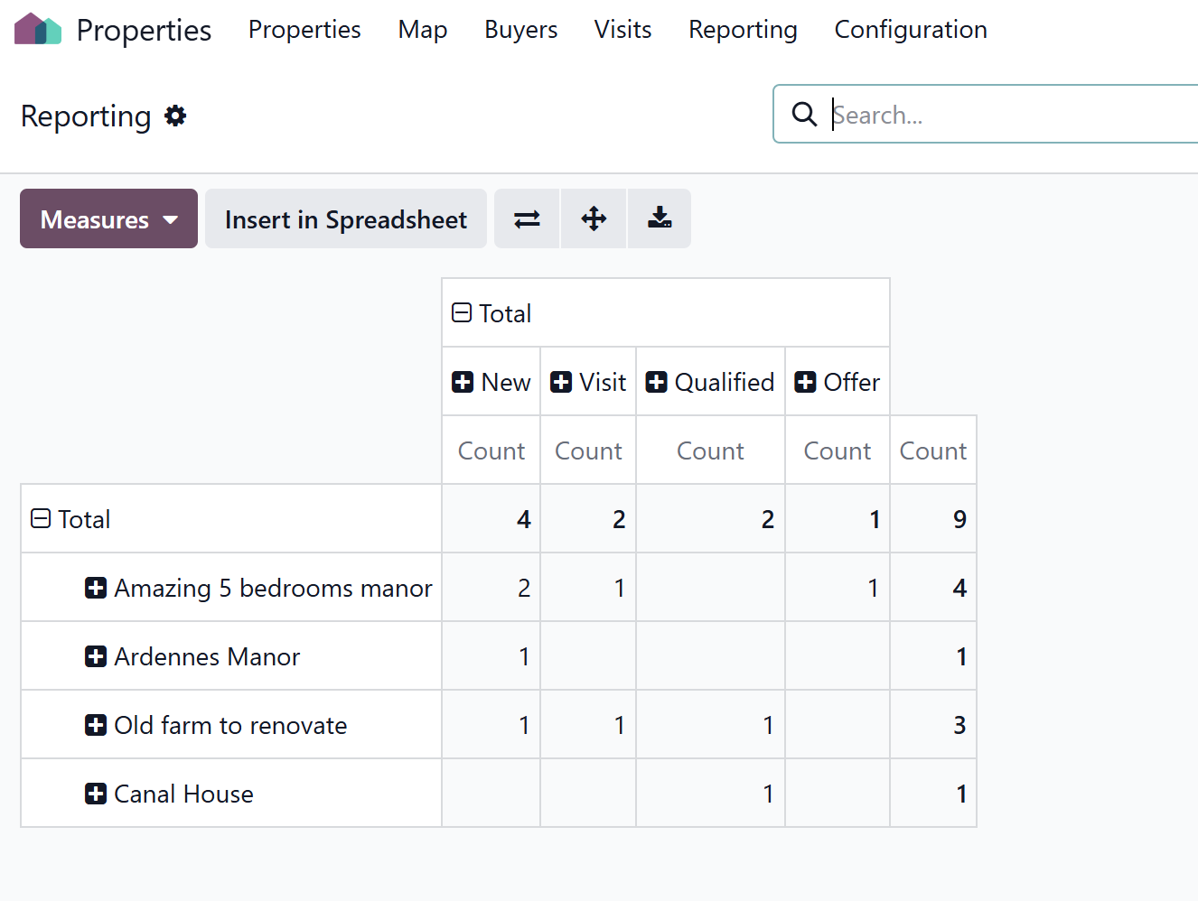

Conclusion
Odoo 19 brings the entire real estate agency workflow under one roof. From the moment a seller submits an enquiry to the day the deal is signed and the commission is invoiced, every step happens within the same platform — connected and trackable.

Frequently Asked Questions

1. Does selecting Real Estate Agency automatically install all the required apps?
Yes. When you select Real Estate Agency as your industry and confirm the database creation, Odoo 19 automatically installs required apps which are configured for a real estate agency
2. What is the Free Estimate feature in Odoo 19 real estate?
The Free Estimate button on the agency website allows property owners who want to sell to submit their property details online. When submitted, Odoo 19 automatically creates a new record in the Buyers pipeline so the agency team can follow up, schedule a site visit, estimate the property value, and onboard the seller — all from within the pipeline.

Ready to implement Odoo 19 for your real estate business? As an Official Odoo Partner in India, Infintor Solutions has extensive experience deploying Odoo for real estate agencies across India and the Middle East. Connect with our team at infintor.com for a personalised consultation and demo.

